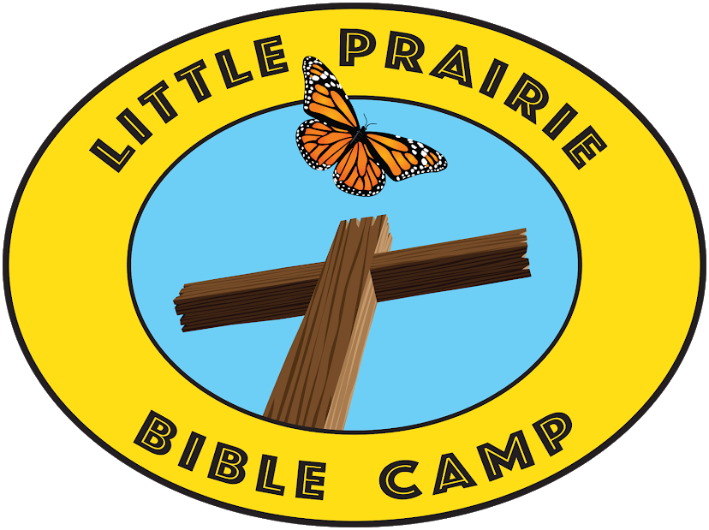

LPBC WINTER NEWSLETTER 2025
NEWS FROM THE COMMITTEES
Site Maintenance—Dub Erisman
We are currently in the process of rewiring the multi-purpose building to repair the fifty-year-old faulty wiring that needs to be replaced. We have added new ground wire and added new lines to make the facility more usable. In addition, we are installing camper hookups underground removing them from the side of our building. This will be completed just in time for the team of Sojourners who will come in May to help with multiple camp improvement projects that include staining the new bridge they built last year and repairing an existing walk bridge that has washed out. We have an upcoming work day on May 3rd that coincides with their visit, and we would love to see you there!
Encampment – Tim Gill
If there has ever been a time for promoting peace, it’s now! Today, Americans clash and cancel one another over just about anything. Sooner or later, conflict can fight its way into your life, polarizing your home, your workplace, and your church. Left unresolved, conflict has the potential to damage and destroy you and your relationships. What do you do? Jesus said: “Blessed are the peacemakers, for they will be called children of God.” Matthew 5:9 The apostle Paul urged the Christians in Rome: “If it is possible, as far as it depends on you, live at peace with everyone.” Romans 12:18 God calls you to be a peacemaker. He wants you to promote peace with others. Let’s face it, most people are ill-equipped to address or resolve everyday conflict. When facing conflict, many choose to either ‘flee’ or ‘fight’ or they settle for faking peace instead of making peace. This year, Little Prairie Bible Camp will focus on what the Bible says about peacemaking. Staff and campers will learn: (1) What the Bible says about conflict and peace. (2) The root causes of conflict. (3) The difference between good and bad conflict. (4) Facing the storms of life with peace. (5) Pursuing peace with God. (6) Peace-faking vs Peacemaking. (7) Forgiveness. (8) Practical steps to resolving conflict in our relationships. (9) What do you do when peace seems impossible?
Beautification – David Garver
A first-time summer visitor to LPBC stated, “This is the prettiest camp I’ve ever seen.” What a motivating comment! There will always be wooded perimeters to clear, limb canopies to raise, and mulching. There’s also large rocks and selected ornamental grasses to be strategically placed that make all the flowers bloom even more beautiful for Spring, Summer and Fall. Additionally, a few smaller mulch beds are being added to assist in mowing by eliminating sharp sidewalk turns around the pool. On the west wall of the Multipurpose Building, a garden dedicated to the Sojourners has been created. They are the dedicated volunteer group from various locales around the country that have been such wonderful manpower assistance to LPBC each Spring. Lastly, a new effort is being made to identify “eyesore” issues around the property and make every effort to eliminate them. Should you care to be a part of the Beautification Committee or see something the Board has overlooked toward making camp even more visually appealing, PLEASE let us know!
Fundraising Committee—David Garver
LPBC’s Spring Banquet has been set for 5:00 p.m. April 5th at the Rolla Congregation’s Family Life Center. One of the first Counselors to serve at camp in the 1970’s, Dr. Tim Baird, has graciously accepted our invitation to be our speaker for the evening. Tim has recently retired as Chair of the Computer Science Department at Harding University, and we are thankful he will be here as he continues to support LPBC over the decades.
A new opportunity for giving has been created and it’s an exciting one! When someone special is celebrating a milestone, please consider LPBC as a very special place for recognizing that special achievement. Should an anniversary, birthday, graduation, or just a special “thank you” wish to be noted, please consider a donation to LPBC with a note for your dedication. It will be listed in the next newsletter and, no doubt, they will feel special that their special day or achievement has helped LPBC accomplish even more!
2024 was a banner year for LPBC in fundraising. To God be the glory for His bounty in making that happen! The Board has worked diligently to be efficient in managing funds, prioritizing and completing maintenance items, making camp beautiful and providing the best camper meals possible. The MOST important task, however, is creating a creative and effective environment for the hundreds of young people to be impacted by God’s WORD. Your continued support is making that happen!
Finance-Jason Derrickson
Thank you for blessing Little Prairie Bible Camp through your donations and time in 2024. The following table shows the source of total income for 2024:
32% Camp Fees
3% Corporate Contributions
5% Congregational Support
10% Donations to Storm Shelter
21% Individual Support
11% Memorial Support
5% Fabulous Fakes
7% Spring Banquet
6% Other Income
As you can see, the camp fees are the highest source of income while individual support is second. We are so blessed and thankful for your support in helping us keep our tuition below average.
Little Prairie Bible Camp will be able to repair several areas at the site while keeping the funds for our yearly startup. Several projects are in the beginning stages while others will be planned out at the right time. We are trying to maintain and repair several current structures.
We have saved around $140,000 for the shower house that will also provide shelter for bad weather. Little Prairie Bible Camp has been able to invest this money in CDs, to increase our savings. We continue to move forward with the design phase of the project.
The mission of the Board for Little Prairie Bible Camp is to use these funds to serve God by offering an opportunity to teach kids and adults about God and allow them to form a relationship with Jesus as well as other kids. As the Board, we are praying that each child has an opportunity to draw closer to God through their experience at Little Prairie Bible Camp. Please join us to pray for this cause. Pray for the Board that we may be good stewards of the finances. Thank you.

HOW CAN YOU HELP?
- We are in need of beef and pork donations for summer sessions.
- We need donations to the scholarship fund.
- We need donations toward the purchase of new “porch swings” built to last for the pergola circle by Noah’s ark. The company provides a decades-long warranty, and they are building them for us at their cost.
UPCOMING EVENTS
April 5th, 5 pm – Spring Banquet at Rolla Church of Christ Family Life Center
April 19 – Tree and trail maintenance workday (we especially need help after the storm on 3/14!)
May 3rd, 9 am – Camp Workday
August 2nd: -- Fabulous Fakes Dinner Show at The Barn in Dixon, MO
Memorials in 2024-2025
Robert Williamson Leroy McGinnis Don Secrest
Bill Miller Virginia Mortland Terry Tabor
Larry Cardin Evelyn Robertson Jack Harris
Jim King John White
Did You Know?
- Individuals and church groups are able to rent the facilities at camp. We have some spots open this summer.
- We would love your help with rising food costs. Your local congregation can help us out by donating specific food items for the summer sessions!
LPBC WINTER VIEW
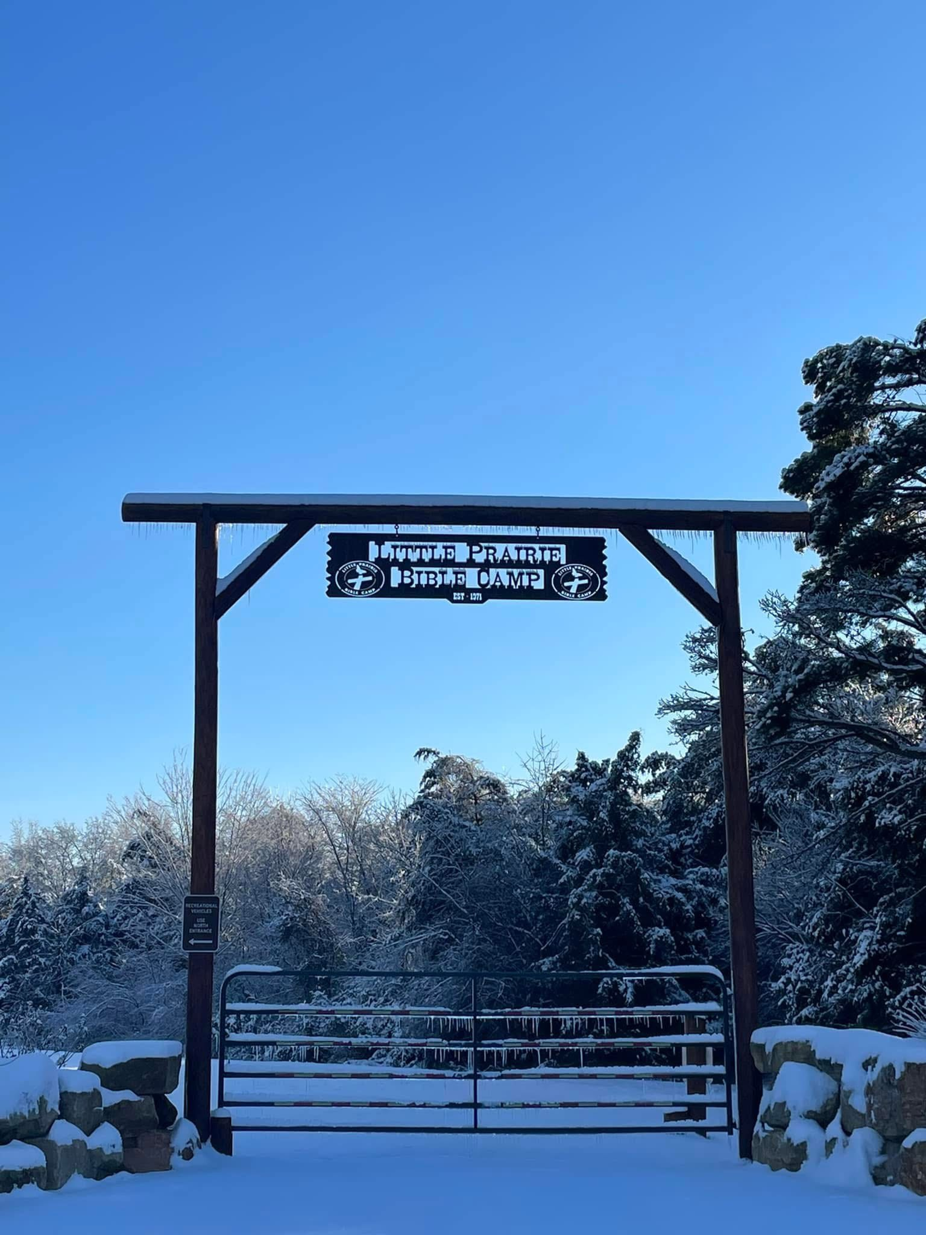
PHOTO BY MISTY WILLIAMSON

